Day 5 - 104608492 - Shirisha Perapagu

Linux commands

Task 1:

Create a Directory with the Name LinuxPractice.

Task2:

Change to the directory

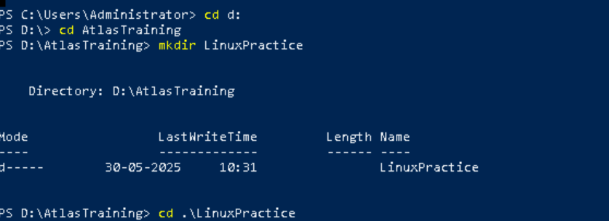

Task 3:

Create a file name TestFile1.txt and add the content to it.



Task 4:

Create a Folder named Dummy and try to delete it.

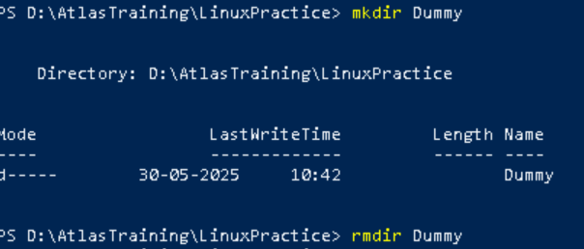

Task 5:

Check the working directory

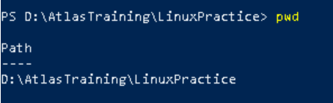

Task 6:

How do you check all the files and directories in the directory you are in?

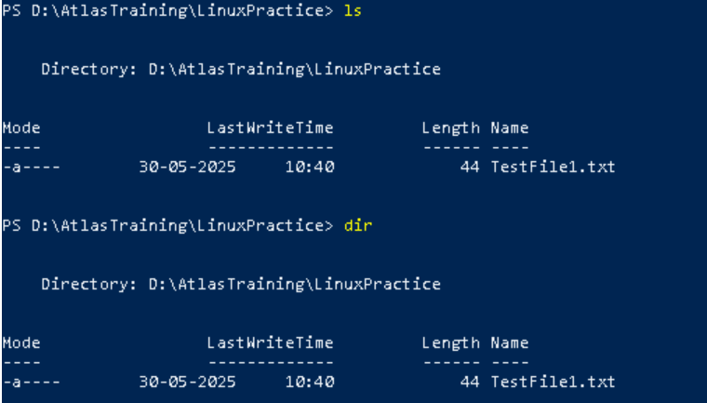

>Used write the content to the file



>> append to file

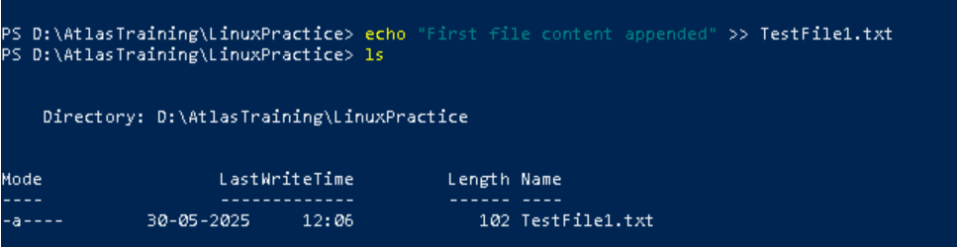

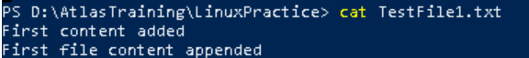

write



Task 7:

Create five files named TestFile2.txt.. TestFile3.txt… and so on till TestFile6.txt

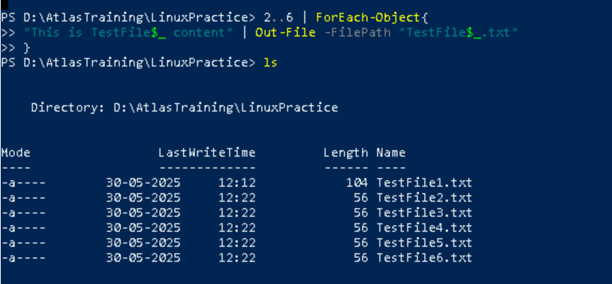

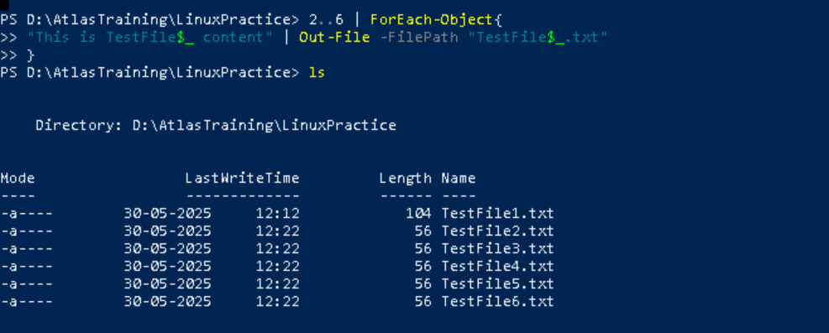

To see the content in each Files

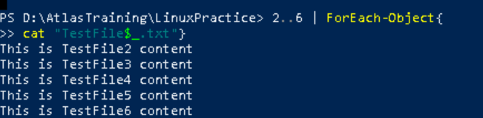

Shorthand command for ForEach-Object ( to see Filename and its content)

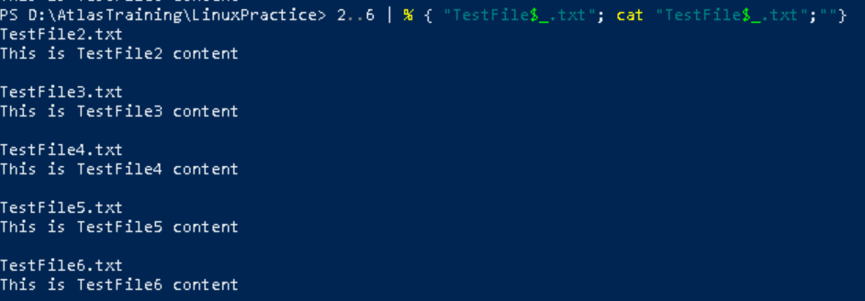

Task 8:

Copy all files from Dir 1(LinuxPractice Directory) to Dir 2

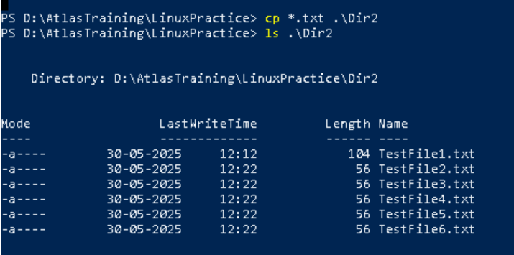

Task 9:

Move all files from Dir 2 to Dir 3 (finally ur Dir 2 should be empty)

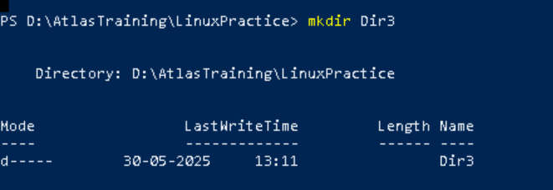

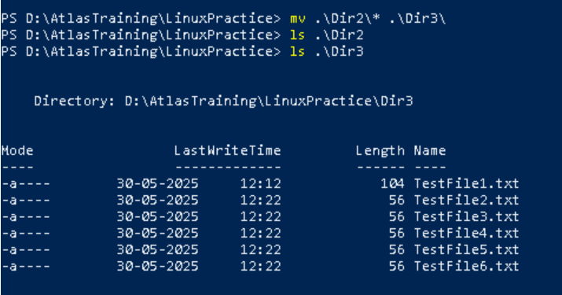

Task 10:

Differnce between **rm** and **rmdir** commands.

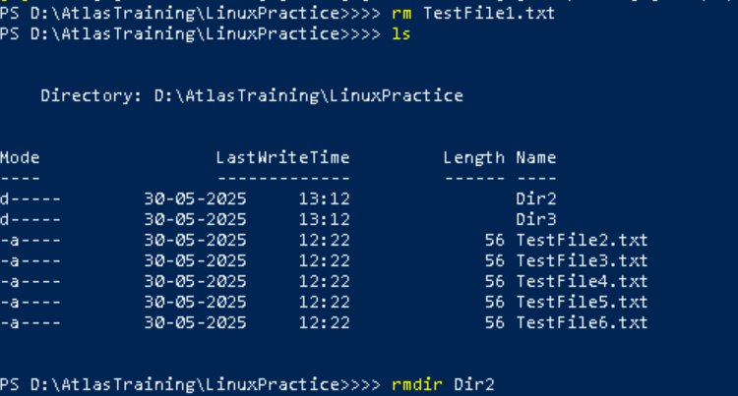

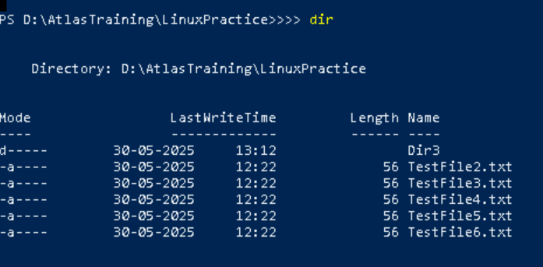

In Gitbash

Task 11:

Use cat command to create a file

And add the dummy text of 2 to 3 paragraphs from the above link Lorem Ipsum.

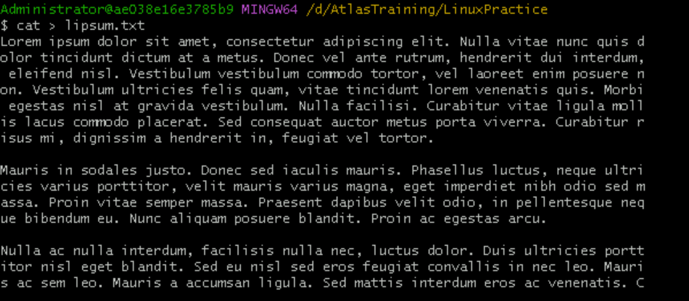

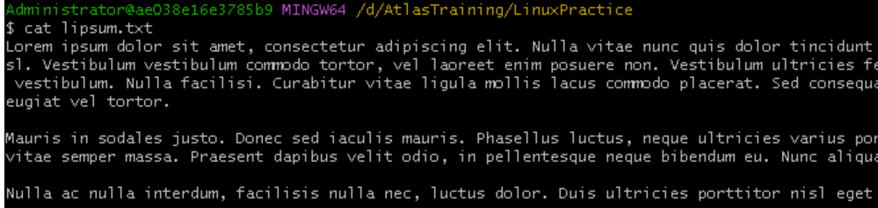

Task 12:

How to get only the top part of your file..

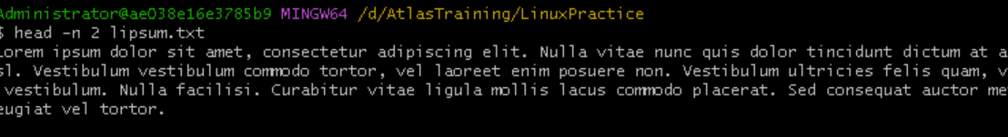

Task 13:

How to get only the last part of your file



Task 14:

Add dummy text of 5 to 6 pages in to the same file

show the file in page by page

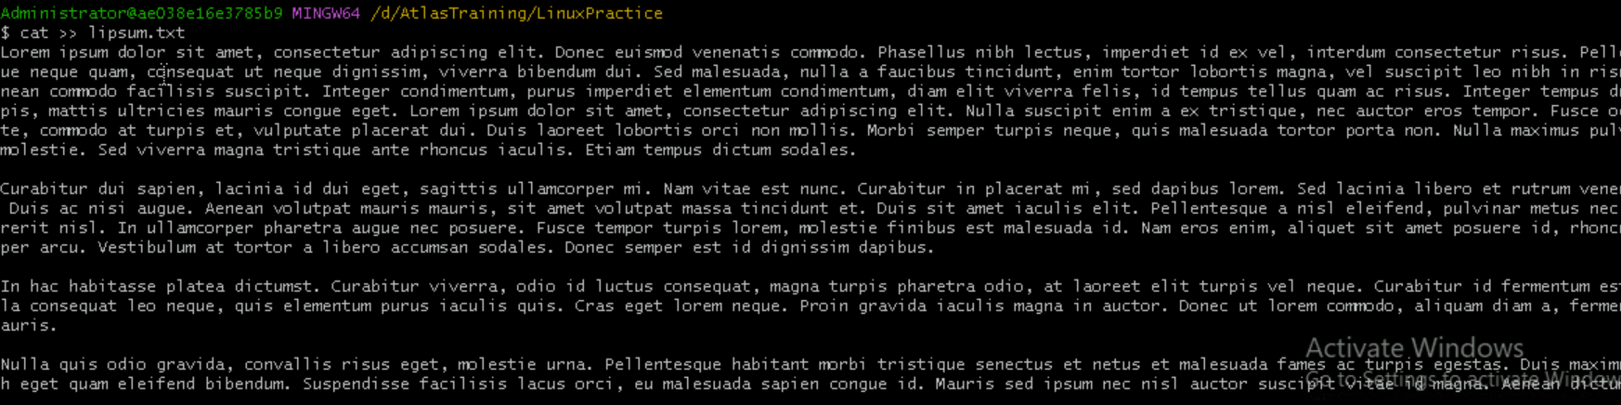

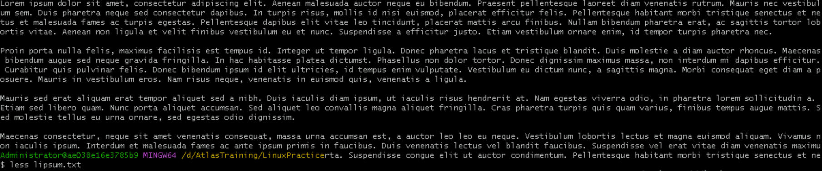

Task 15.

more lipsum.txt

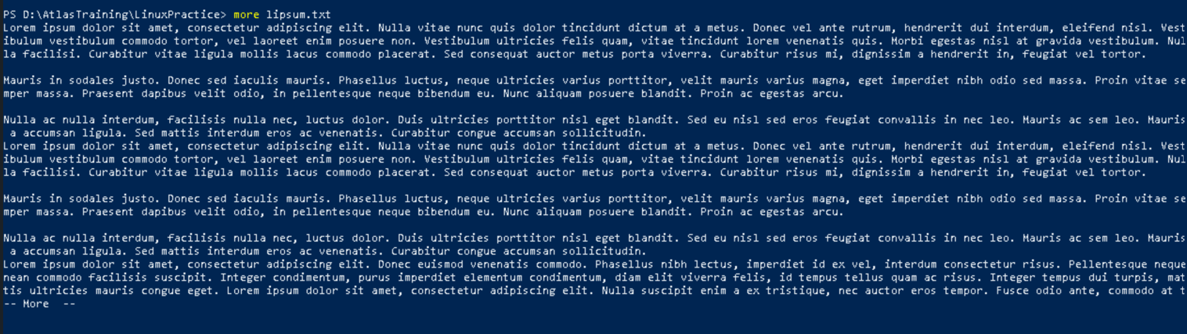

Task 16:

echo with and without -e

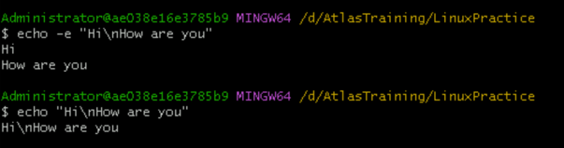

Task 17

Difference between ls and ls -l command

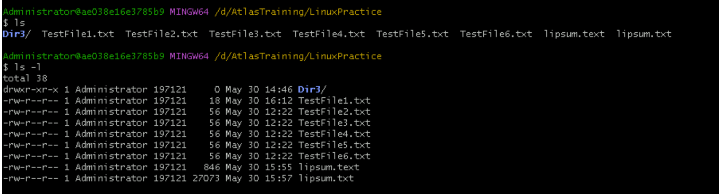

Task 18

Create a file using **touch** command , **cat** command and **echo** command

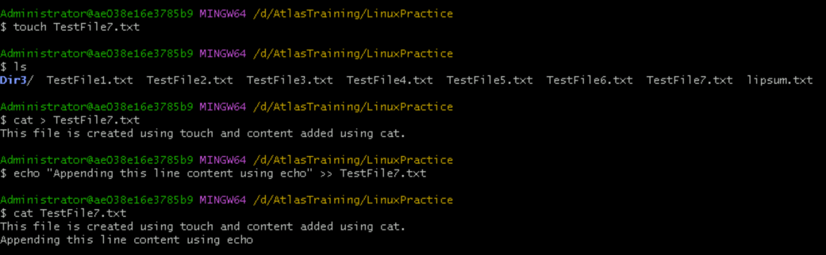

Task 19

cal

not working in gitbash and powershell

But working in wsl.

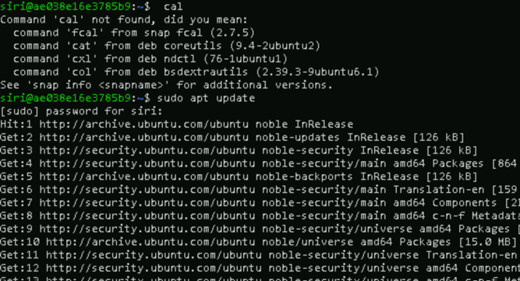

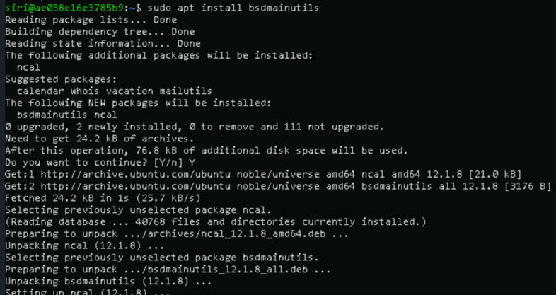

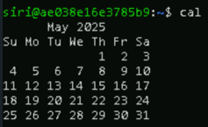

Task 20

Go back to 1 directory .. at a time

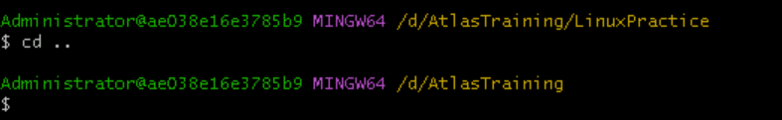

Task 21:

How to know whose user u are working on ?



Task 22:

 who is peeping into your system..

working in wsl

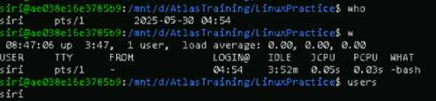

Task 23

check how much disk space is consumed..

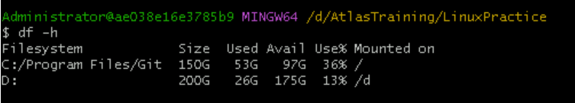

Task 25:

Find the list of all files ending with .txt



Task 26

How to check all the hidden files in Linux



Task 27:

What is the difference between . and .. in linux

. (single dot)

Refers to the current directory itself.

cd .

. means current directory, changes won’t be visible as we are telling shell to change directory to where I already am.

.. (double dot)

Refers to the parent directory of current directory (move one level up)

cd ..

so here .. means parent directory, so here shell understands that we want to go up one level.

We can also go up multiple levels up like this cd ../..

create a file using vi editor



I to insert

Esc and type :wq to exit

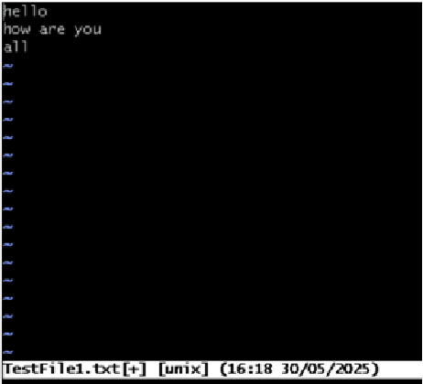

Task 29:

How to find the no of words in the file

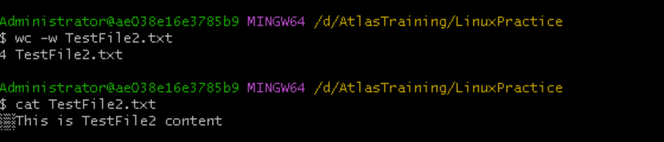

Task 30:

cat -b myfilename.txt command

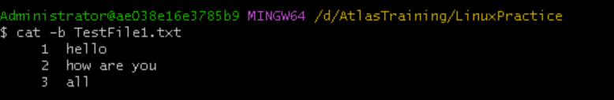

Task 31

wc with 2 or more files

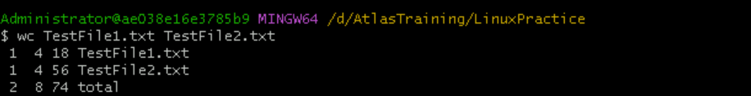

Task 32:

Copying one file content to another file

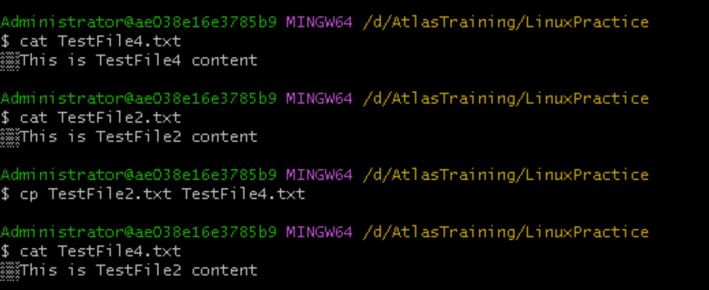

Task 33:

Renaming a file



Task 34:

How to delete multiple files

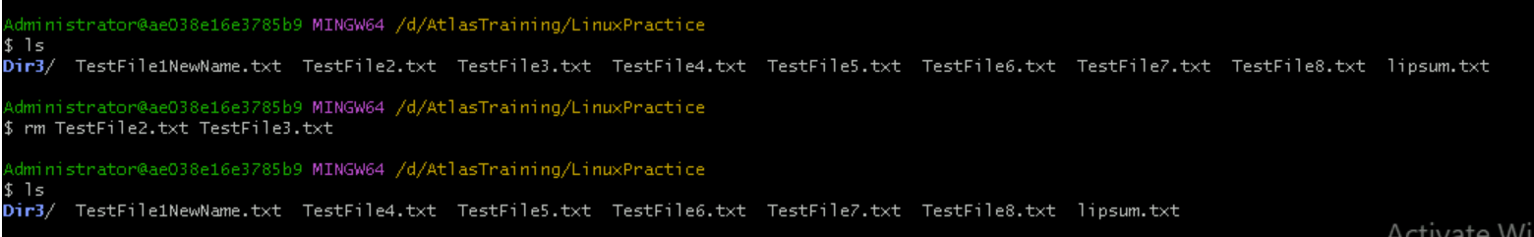

Task 35:

Change directory to root directory

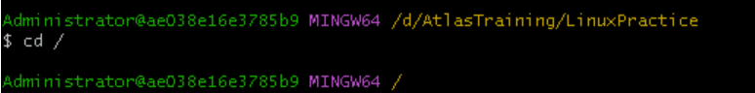

Task 36:

Change directory to home directory

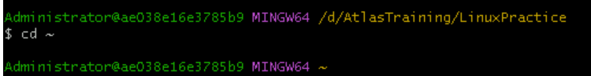

Task 37:

Move to different users home directory

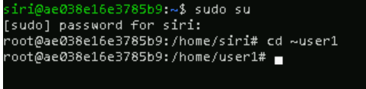

Task 38

chmod

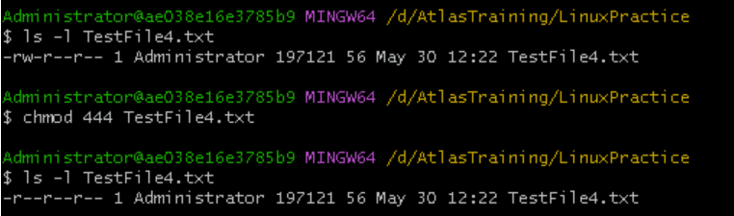

cat /etc/passwd - to view user/system accounts

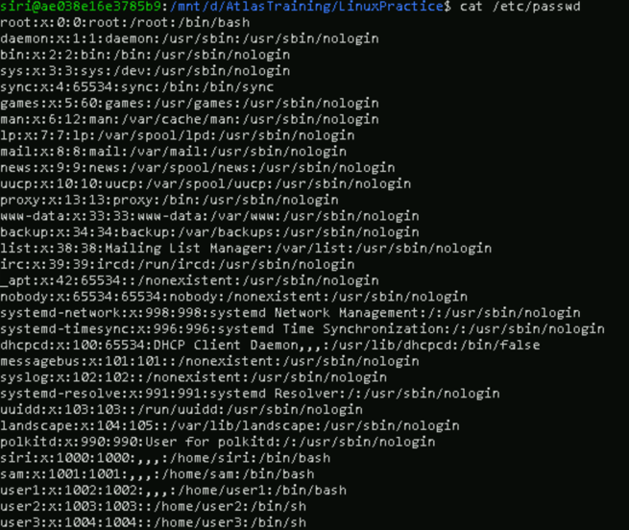

To view only the users/service names

